About us:
The Mumbai Maritime Training Institute has a commitment to quality training. The Institute is ISO 9001:2015 Quality certified by DNV. All the courses offered at MMTI are approved by DG Shipping. MMTI has been graded by DNV as A1 (outstanding) Institute. The strength of each class is limited to facilitate individual attention. You can discuss your individual needs, problems and requirements with the Institute and the faculty for the competency courses. Even after your exams, you are always welcome to approach us for any guidance.
MMTI is also selected as preferred institute by FOSMA- MASSA for competency & modular courses Several “Best Training Institute” and “Best Student” awards are testimony to this fact.
Located in the heart of Mumbai at Andheri, we are close to Andheri Railway Station, a couple of hundred meters to two Metro lines and are also serviced by several bus routes & taxi services and easily accessible from Airport.

The MMTI is run professionally and promoted by

CAPT. C. L. DUBEY, DIRECTOR & OWNER:
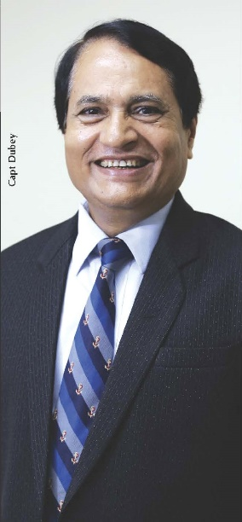
- Capt. C. L. Dubey is graduated in Science, Master Mariner & Extra Master.
- He has 20 years of sailing experience and 34 years of experience as Maritime Trainer.
- He is a paper setter, Moderator and examiner in Mumbai University.

- He is a paper setter and examiner in D. G. Shipping, Govt. of India.
- Capt. C. L. Dubey had been fellow and warden of The Company of Master Mariners of India (CMMI).
- Capt. C. L. Dubey was a member of Indian Delegation of “Human Element, Training and Watch Keeping” Ninth Session (HTW9) meeting in IMO London from 06.02.2023 to 10.02.2023 and again for HTW 10 & HTW 11 for on-line attendee.
- Author of many Maritime Text books which are being used by Maritime Students in India and abroad.
- Capt. C. L. Dubey is “Competent Person” appointed by IMO in Feb 2024.

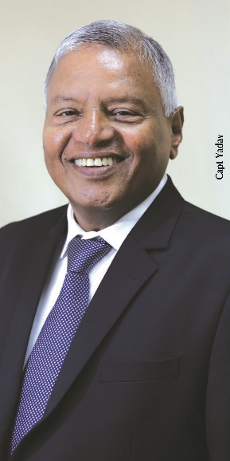
****************************************************************

CAPT. O. P. YADAV, DIRECTOR & OWNER:
- Capt. O. P. Yadav is a Master Mariner.
- He has 26 years of sailing experience and 28 years of experience as Maritime Trainer.
- He is in a panel of Oral examination in D. G. Shipping, Govt. of India.
- Capt. O. P. Yadav has been member of The Company of Master Mariners of India (CMMI).
****************************************************************

CAPT. F. X. COUTINHO, PRINCIPAL:
- Capt. F. X. COUTINHO is Master Mariner.
- He has 12 years of sailing experience and 22 years of experience as Maritime Trainer.
- He is in a panel of Oral examination in D. G. Shipping, Govt. of India.
- Capt. F. X. COUTINHO has on panel of paper correction group in D.G.Shipping.
****************************************************************
CAPT. M. R. MARTINS, VICE-PRINCIPAL:
- Capt. M. R. MARTINS is Master Mariner.
- He has 10 years of sailing experience and 12 years of experience as Maritime Trainer.
- He is in a panel of Oral examination in D. G. Shipping, Govt. of India.
- Capt. M. R. MARTINS has on panel of paper correction group in D.G.Shipping.

****************************************************************

Faculty section should be with photographs

****************************************************************
Required page for candidates Testimony / Feedback
****************************************************************

WHILE BOOKING THE COURSE, WE REQUIRED CANDIDATE TO SELECT THE COURSE AND ADD THE FOLLOWING DETAILS:
CANDIDATES NAME, HIS INDOS NO., HIS MOBILE & EMAIL ID, CDC NO & COC NO.

PLEASE ADD FOLLOWING NOTICE: RELEVANT DOCUMENTS TO BE SENT ON modulartwo@mmti.co.in

****************************************************************
We would like to add Bank details & QR CODE for D.G.Shipping approved courses and UK MCA / Value addition courses separately.

WHILE TAKING BOOKING FORWARD, PLEASE ADD FOLLOWING NOTICES:
After depositing the fees in a bank please send us the scanned copy of deposit slip for seat confirmation.
Also, Please call us before transferring the Money for seat availability.

****************************************************************

We want to add our social media links to redirect the relevant pages.

****************************************************************

Library:
- E-books to only selected people, like only library computers / LOGIN holders should have access it (from library login)
- Library module in software needs changes Library photos
- Options to update the Book lists
- Options to search book by name, author, publication etc
- Issuing the books to the candidates and faculties
- Issuing the clearance to the candidate
- Uploading of Soft copies of books & link of E-books

Note: Photos & List of the books along with authors will share soon
****************************************************************

